**DMAIC REPORT OF AMAZON SALE PREDICTION**

DMAIC is an acronym for Define, Measure, Analyze, Improve, and Control. It is a guideline for delivering sustainable and quantifiable results.



**Introduction:**

This report aims to analyze key performance indicators (KPIs) related to Amazon sales to assess the company's performance and identify areas for improvement. By examining these KPIs, we can gain valuable insights into our sales performance on the Amazon platform and make data-driven decisions to optimize our sales strategies.

**Methodology:**

The analysis was conducted by collecting sales data from Amazon's seller central reports and leveraging various data analytics tools. The data covers a specific time frame, and specific KPIs were chosen to evaluate different aspects of our sales performance on Amazon.

* CTQ(Critical to quality ):-are the key attributes of a product or service that your customers have defined as being important.
* Key Performance Indicators (KPIs):

The following KPIs were analyzed to assess our sales performance on Amazon:

**DEFINE**

**Define is the first phase that shows in which area needs improvement**

This project shows our three main problems and how to resolve the problem

**First statement**

Annual sale date selection: Every e-commerce website’s priority goal is to sell as many products and increase the number of customers. for increasing customer engagement and selling product company have to organize the sale. Sales play a very big role in engaging more buyers, which helps to generate more revenue for the company In this case, we have to find the right time frame to launch the 3 best consecutively days for sale in the year

* **KPI:** In this case, we have to find the right time frame to launch the 3 best consecutively days for sale in the year
* **CTQ:** Both company and buyers of the company.

**Second statement**

Supply chain management : Our second problem statement is to find which products demand is high and which products demand is least . this will give the idea that company have to increase the warehousing of the product or decrease it in that particular area . With the help of this supervision of items in the warehouse according to the demand in the range will lead to faster delivery of items leading to better buyer experience and the company get which areas have same demand for two different area,state or region there is no need to build another warehouse

This will help to save the cost of many things

* + **KPI:** City , states , quantity of product and their sales ordered in the location.
  + **CTQ:** Cost-efficient to the company and a pleasant experience for the buyers

**Third statement**

Association/Recommendation: Recommending customers appropriate items according to the previous buys of the same product pairs best combination with the product ordering leads to customers buying the recommendations as well

* **KPI:** Quantity of Products ordered matched by same Order ID,.
* **CTQ:** Giving advice of what to buying pair is gud with the product he is selected to buy.the sale will surely go to high and that will help company to generate more revenue this is our main goal

**MEASURE**

* We have 186850 rows and 6 columns in this data first we remove the null and missed value with the help of data cleansing number of counts of null and missing values is 545
* **After cleansing, we got 186305 data and we have done all analysis on that data**

The data include the following features:

* Order ID: The order ID is a special identification number given to each placed order. If multiple items are ordered in a single order, then their Order ID will be the same.
* Product: The Name of the product ordered.
* Quantity Ordered: The number of units of that specific item ordered.
* Price Each: The price of each item
* Order Date: The Date and time of the order placed.
* Purchase address : address of the customer who purchased a product from the website

These are given in dataset but for analysis we have to add some more coumns and we also measure on that measures

The columns we added :-

* Sales : This column tells us the amount hom much revenue generate from a particular order it was calculated after multiplying the values of quanity ordered and price of that each item
* Month: The name of the month on which the order was placed.this column is added from the order date column
* Day: The day of the month on which the order was placed. this column is also added from the order date column
* Hour: The time of the day at which the orders are placed. this column is also added from the order date column

**ANALYZE**

1 . Find the most appropriate month , day and time for a consecutively 3 day sale was the first problem statement for solving this problem we created 3 graphs to show which is best month , days and hour with the highest sales and quantity ordered

The graph shows X AXIS and Y AXIS

X axis : Sales (bars) and Y axis : Quantity Ordered (line)

**MONTHLY REPORT OF SALES AND QUANTITY**

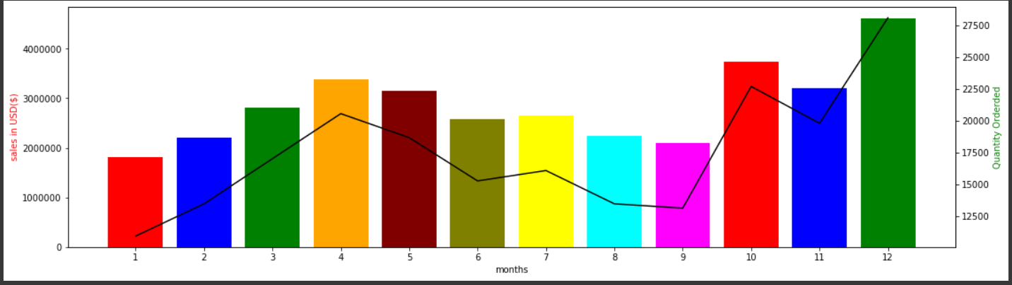

This bar shows highest sales of year and quantity ordered is in month of **DECEMBER**

This shows the best month for sales is **DECEMBER**

**DAY SALES REPORT OF SALES AND QUANTITY**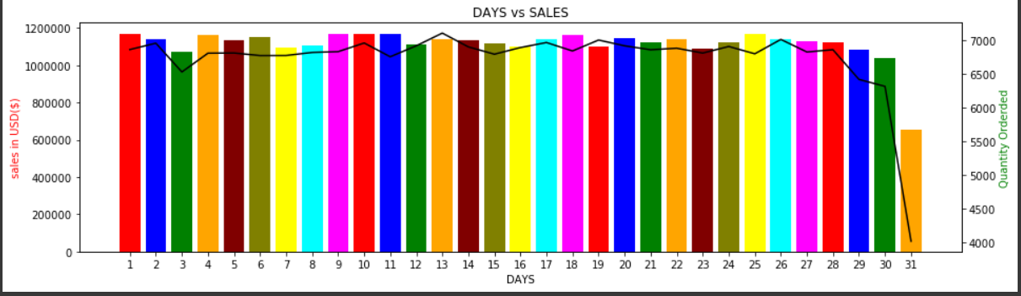

This bar shows all the sales and quantity ordered from each day in December month

We have to choose 3 consecutively days which is best for sale

We choose 20 , 21 ,22 for 3 days sale because these dates are near the Biggest occasion Xmas and in these day sale is consecutively gud and there are no high up and downs in from the data of last year in these 3 days the customer is showing more interest to buy products

**HOUR REPORT OF SALES AND QUANTITY**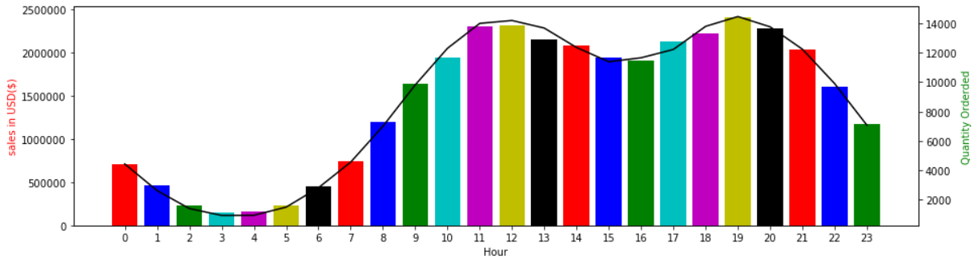

This Bar Shows All 24 Hours And From We Have To Find Which Is Best Hour To Start The Sale Because We Have A Time 3 Days Time Limit For Sale So Our Focus Is Also Have To Not The Waste Time Of Sale Because If We Start From The Midnight 12:00 Then You Can See The Sale Is Going Down And Sale Is Going Up From 5:00 Am And These 5 Hours Is Our Website Sales Couldn’t Generate Gud Revenue , If We Can See From 10:00 Am The Selling Of Product Is Already On Moderate Level And After 10 :00 The Customer Purchasing Of Products Is Going High But Not Going Very Low In Whole Day

2. : Our second problem statement is to find which products demand is high and which products demand is least . so for this 2 graphs is shown below the one is showing top 5 selling products and top 5 least selling products from each state wise. with the help of these graphs we can find from which state the warehousing needs for which product or for which product there is no need of warehousing

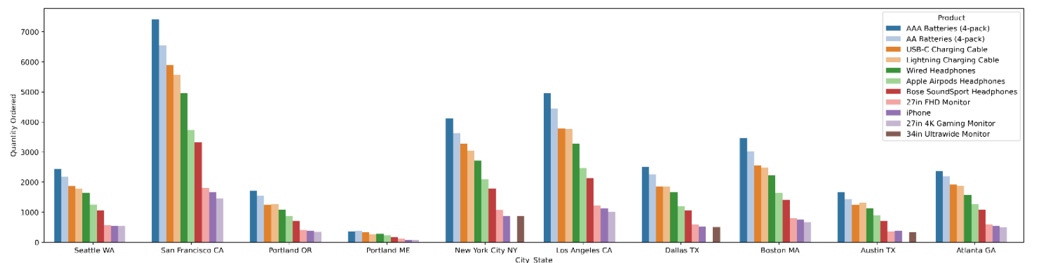

**In this graph the top 5 selling products quanitity is given**

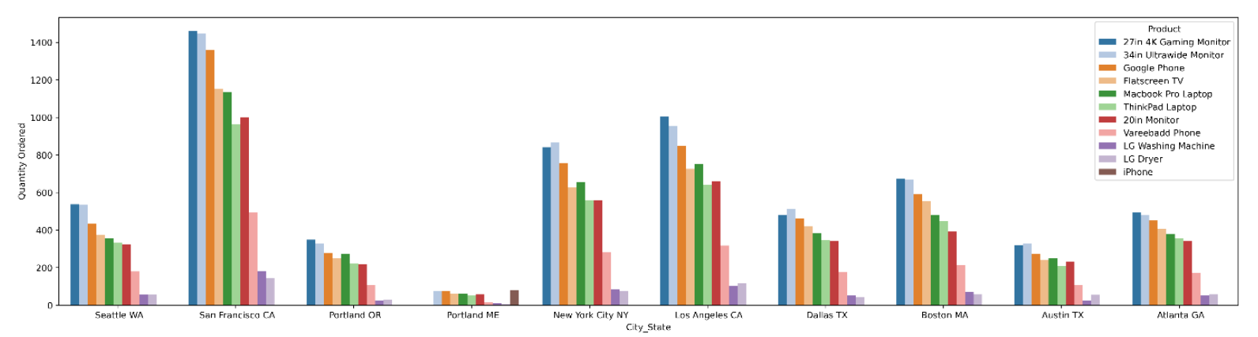

**In this graph top 5 least selling product quanity ordered is given**

3. Our last problem is Recommending the best products combination from previous sales analysis we got the top recommendation . Two graphs have been made; the first displays the purchases of two things together, while the second displays the purchases of three products together.

The following two graphs display:

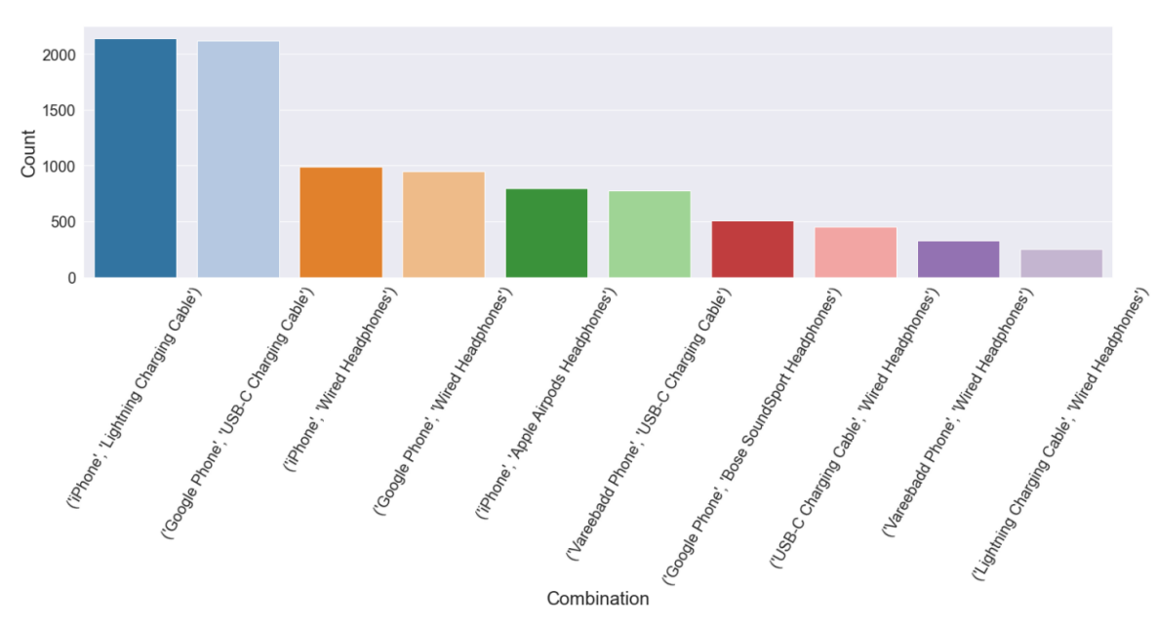

**This graph shows Two best things pair together**

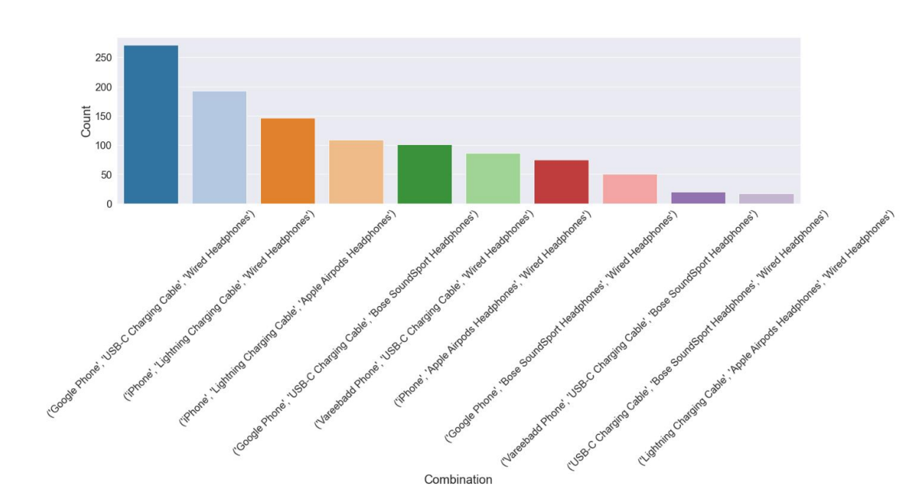

**This graph shows Three best things pair together**

Conclusion:

In conclusion, analyzing key performance indicators related to Amazon sales provides valuable insights into our sales performance, market position, customer satisfaction, and advertising effectiveness. By leveraging these insights and implementing the recommended strategies, we can optimize our sales strategies on Amazon and drive growth and profitability.

Thank you for your attention to this report.

Best regards,

Ruchir Tripathi

STUDENT(ASMS)

ruchir.rk.tripathi@gmail.com

9936252624